FEMA Public Assistance Covid-19 Brief

Eligible Entities
Under President Trump’s COVID-19 Emergency Declaration, FEMA may provide reimbursement for emergency protective measures through its Public Assistance Program. Local governments and certain private non-profit organizations (ex: hospitals, schools, churches, etc.) that assist with COVID-19 emergency measures are eligible to apply.

Applicable Activities
Emergency measures can include:
- Emergency medical care
- Medical sheltering
- Purchase and distribution of food and other consumable supplies
- Communications of general health and safety information
- Emergency Operations Center costs
- Training specific to the declared event
- Disinfection of eligible public facilities
- Non-deferrable medical treatment of infected persons in a shelter or temporary medical facility
- Emergency medical transport
- Use of specialized medical equipment
- Purchase of personal protective equipment and hazardous material suits
- Security and law enforcement
- Reimbursement for state, tribe, territory and/or local government force account overtime costs
For a complete list, review FEMA’s March 19th press release.

Reimbursement
For local governments and eligible non-profits, the federal government will reimburse 75% of applicable costs. The state of Kentucky will cover 12%, and the applicant is responsible for 13%.

Next Steps
- Submit Request for Public Assistance at the PA Grants Portal Page.
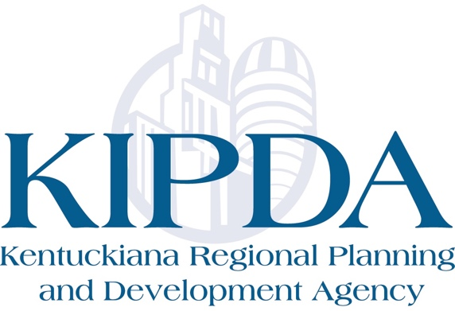
- Keep track of all COVID-19 related expenses.

